**The rise of food costs in America**

Brittney N. Orais-Bonheimer

Western Governors University

Table of Contents

A. Project Highlights 3

B. Project Execution 4

C. Data Collection Process 8

Data Collection Methods 8

The data I am using is the National Weekly retail food sales from the USDA.gov website. This data is public and from the government so it is trusted to be accurate. The data will be downloaded as an Excel file from the USDA.gov website. Since the data is already in an Excel spreadsheet, it will need very little cleaning and formatting. I will then open the file in Excel, and review both the ‘National Total’ and ‘National by Subcategory’ tabs. I then checked both datasets for any formatting issues or rows that need to be deleted before I could upload them into Jupyter Notebooks. I saved the Excel file and uploaded it to jupyter notebooks for data analysis. The data is also only reported from 2019-2023 so we are unable to calculate the average percentage change in 5 years based on this data to compare to the forecasted percentage change in 5 years. 8

Observations on Quality and Completeness of Data 8

C.1 Advantages and Limitations of Data Set 9

D. Data Extraction and Preparation 10

E. Data Analysis Process 12

E.1 Data Analysis Methods 12

E.2 Advantages and Limitations of Tools and Techniques 12

E.3 Application of Analytical Methods 13

I first plotted the weekly dollars per unit totals to get a visual for the rising costs over the past few years: 13

F Data Analysis Results 16

F.1 Statistical Significance 16

F.2 Practical Significance 18

F.3 Overall Success 19

G. Conclusion 20

G.1 Summary of Conclusions 20

G.2 Effective Storytelling 20

G.3 Recommended Courses of Action 24

H Panopto Presentation 25

References 26

# A. Project Highlights

**A1. Research question:**

The question asked with this project was: If the cost of food continues to rise at the same rate, how much will food cost 5 years from now? Since our organization is a nonprofit working towards ending food insecurity for families, we want to be able to predict how much we will need to grow in the next 5 years to keep up with demand as well as gain more donor support.

**A2. Project scope:**

This project's scope was to create a predictive model using Python in Jupyter Notebook. This model was an ARIMA model that could forecast future food costs based on current weekly retail food sales data from the USDA.gov website. The predictive model can forecast the average percentage change in the cost of food 5 years from now. This model was used to forecast the average cost and percentage change in the cost per unit of selected examples of food subcategories using the current data from the USDA.gov website. The predictions included scatter plots of the current data showing the current rate of inflation for all food as well as food subcategories. The main constraint was the data is weekly retail food sales as a total amount and total unit amount. Although the data is divided into categories and subcategories, it is not possible to get detailed information on very specific food items. The data is also national, not local. This project did not include data predictions for any other timeframe other than 5 years. It did not include the average food cost per unit based on food categories. It also did not include the average price per unit of current food costs.

**A3a. Solution Overview Tools:**

The project was done using Excel and Python in Jupyter Notebook. The Python packages that were used included pandas, numpy, matplotlib, sklearn, DateTime, and pmdarima. The data sets used were from the USDA.gov website and were downloaded in Excel files. I chose this data because it is public government data that provides the weekly retail sales of food from 2019-2023. This data was used to forecast food costs in 5 years. Python in Jupyter Notebooks and all of the listed Python packages provided an environment to properly analyze and build our ARIMA model for forecasting. This was used to forecast the food costs in 5 years based on the data we had. Excel was used when the data was first downloaded before it was uploaded into Jupyter Notebook.

**A3b. Solution Overview Methodologies:**

I used multiple methodologies when working on this project. Exploratory analysis was used to determine which categories of food had the highest inflation. This was done by creating scatter plots showing the different subcategories of food and the cost each week. Predictive analysis was then used to forecast future food costs as well as regression analysis and modeling to accurately predict future data points. This was done by creating an ARIMA model in Jupyter Notebook using various Python packages. The ARIMA model is a type of regression model that uses time series data to forecast future data points. With the ARIMA model, data is first plotted and analyzed. Data used in ARIMA modeling must be stationary, which means the data is consistent over time. If the data is not consistent, it is nonstationary and will need to be transformed to become stationary. Using the Dickey-Fuller (ADF) test, we can determine if the data is nonstationary by looking at its p-value. If the data is nonstationary, we can use a process called differencing to remove changes in the time series data and make it stationary. We can then perform the ADF test again to verify the data have been transformed properly.

# B. Project Execution

**B1. Project plan:**

If inflation on food prices continues to rise at the same rate, then many Americans will find it difficult to feed their families because the cost of food will become unaffordable within the next 5 years.

Using ARIMA modeling I was able to predict the cost of food in the future based on the rapidly rising inflation rate.

**Goal**: The creation of a prediction model that would accurately forecast future food costs. This was used to show stakeholders the growing need for expanded services and funding for the nonprofit.

* **Objective** 1.1: Determine what the cost of food will be in 5 years based on historical data using the ARIMA model.
  + - **Deliverable** 1.1.1: Provide the average percentage change of food costs in 5 years as determined by ARIMA modeling and current weekly retail food sales data from the USDA.gov website. ARIMA modeling forecasts future data points on time series data like the weekly retail food data. Through this process, we were able to forecast inflation rates based on the current accelerated rise in food costs.
    - **Deliverable** 1.1.2: Provide examples of the cost of different staple food items in 5 years: eggs, poultry, and oils using the ARIMA model. This was achieved by analyzing the data to find food items that have the largest rate of inflation from the weekly retail food sales data we downloaded from the USDA.gov website. This data includes data broken down by food category and subcategory. A scatterplot was used to find subcategories that have high inflation rates currently. Then the ARIMA model was used to forecast these food costs in 5 years. This data was used to provide perspective on what food prices are predicted to look like in 5 years.

**B2. Project planning methodology:**

I used the waterfall methodology for this project.

* Requirements – The requirements were needed upfront for this project. This included reviewing the scope of the project and discussing the assumptions, success metrics, and timeline with stakeholders. I created a project plan including all of the people who would be involved in the project and discussed everyone’s expectations of the project.
* Design – Determined the data and tools needed for this project as well as deciding which analysis methods were used. Designed the timeline and deliverables. The data used was the weekly retail sales of food data from the USDA.gov website. This data was analyzed with Python in Jupyter Notebook to find an average food cost per unit. This was then used to create a predictive model to forecast future food costs based on the current rate of inflation. Since this was time series data, I used the ARIMA model to forecast future data points.
* Implementation – Collected the data needed and then used data analysis tools to forecast future data points. Created and implemented models to make accurate predictions and document each step of the process. I downloaded the data from the USDA.gov website. This data was in an Excel file. The data was reviewed in Excel and then uploaded to Jupyter Notebook for further analysis using Python. Once the data was analyzed, I created the ARIMA model and created data plots with the forecasted food costs. This was then used to find the average percentage change.
* Verification – Verify that all code is working correctly and create data visualizations that portray data point predictions accurately. I carefully reviewed the data visualizations as well as used the dickey-fuller test to verify if the data was non-stationary. The auto ARIMA model fits the data automatically to ensure accuracy when forecasting data points. Once the coding was complete, I verified all code was working correctly and the data visualizations looked accurate.
* Maintenance – Since this is going to be used once, no maintenance is needed on this project. We could potentially use the same model for future forecasting so I will be saving the code used to make recreating the project in the future quick and easy.

**B3. Timeline and Milestones:**

|  |  |  |  |
| --- | --- | --- | --- |
| **Milestone or deliverable** | **Duration**  **(hours or days)** | **Projected start date** | **Anticipated end date** |
| Collecting the data needed to the analysis | 1 hour | *10/25/2023* | *10/25/2023* |
| Cleaning the data if needed | 2 hours | *10/25/2023* | *10/25/2023* |
| Analyzing the data | 2 hours | *10/25/2023* | *10/25/2023* |
| Using various data visualizations to further analyze the data | 2 hours | *10/25/2023* | *10/25/2023* |
| Create the ARIMA model and use to forecast food costs in 5 years | 4 hours | *10/25/2023* | *10/26/2023* |
| Calculate the average percentage change in food costs in 5 years | 1 hour | *10/26/2023* | *10/26/2023* |
| Create the ARIMA model and use to forecast specific food costs in 5 years (eggs, poultry, ect) to use as examples. | 3 hours | *10/26/2023* | *10/26/2023* |
| Calculate the percentage change in example food costs in 5 years | 1 hour | *10/26/2023* | *10/26/2023* |
| Create notes in Jupyter notebook using markdown language explaining every step. | 4 hours | *10/26/2023* | *10/27/2023* |
| Show results to stake holders | 1 hour | *10/27/2023* | *10/27/2023* |

# C. Data Collection Process

## Data Collection Methods

## The data I am using is the National Weekly retail food sales from the USDA.gov website. This data is public and from the government so it is trusted to be accurate. The data will be downloaded as an Excel file from the USDA.gov website. Since the data is already in an Excel spreadsheet, it will need very little cleaning and formatting. I will then open the file in Excel, and review both the ‘National Total’ and ‘National by Subcategory’ tabs. I then checked both datasets for any formatting issues or rows that need to be deleted before I could upload them into Jupyter Notebooks. I saved the Excel file and uploaded it to jupyter notebooks for data analysis. The data is also only reported from 2019-2023 so we are unable to calculate the average percentage change in 5 years based on this data to compare to the forecasted percentage change in 5 years.

## Observations on Quality and Completeness of Data

The data was clean and complete when downloaded, there are a few formatting issues that will need to be fixed before uploading to Jupyter notebooks. The data was downloaded as an Excel file from the USDA.gov website. I then opened the file in Excel, there were two tabs I was interested in, ‘National Total’ and ‘National by Subcategory’. I reviewed both tabs, there was a header in both that needed to be deleted from the first row. That way, the column names would upload correctly in the data frame. I formatted the ‘Date’ column as the date and the ‘Dollars’ and ‘Unit sales’ columns as numbers in both tabs to ensure the correct data types when uploading to the data frame. Lastly, there were multiple rows at the end of each tab that explained certain variables. Since these rows would create an issue when analyzing the data, they were deleted as well. I saved the Excel file, then uploaded it to jupyter notebooks.

Since this project was going to be seen by many different stakeholders in our organization, I wanted to use data that was public so that privacy and security would not be a big concern. Data that comes from government websites such as USDA.gov are publically accessible and do not contain sensitive information.

* Data governance –I was the only person working on this project. Once the data was downloaded from the USDA.gov website, I ensured that the data was cleaned and that quality and completeness were maintained throughout the data analysis process. I documented the process as well in Jupyter Notebooks using markdown language to ensure the analysis could be duplicated if needed.
* Privacy – The data did not contain any information that was not public. I carefully reviewed both datasets to confirm that the information did not contain any sensitive information.
* Security – The only security concern was to ensure the data integrity. The data files will be kept in a secure file that only I will have access to.
* Ethical, legal, and regulatory compliance considerations – No considerations are needed since this data is public and does not include any sensitive information.

## C.1 Advantages and Limitations of Data Set

The data from the USDA.gov website is public information from the government so it is a trusted source and easy to collect. These datasets are appropriate for this project because they contain the weekly retail food sales for the nation, which were used to accurately fit the ARIMA model to forecast future food costs based on the data provided here. The datasets were downloaded from the USDA.gov website as an Excel file with two tabs. One has the weekly retail food sales totals for the country. This includes columns with the date reported, total dollars spent, and total unit sales. Multiple other columns were not needed for this analysis. This information was used to produce an average dollar amount per unit per week which was used to fit the ARIMA model and forecast future data points. I also used this data to create scatterplots to analyze the inflation rate from 2019 to 2023. The other tab has the same columns but also includes columns for the food category and subcategory. This was used in a similar way to produce an average cost per unit for different subcategories for example food items, eggs, oils, and poultry. I used this data to create scatterplots and for the ARIMA model for the specific food cost examples to show shareholders and have a better perspective of what common food items are predicted to cost in 5 years. The disadvantage of these datasets was that they are weekly totals in dollars and total units sold. This meant that we had to find the average cost per unit for our analysis. The data was also only reported from 2019-2023 so we were unable to calculate the average percentage change in 5 years based on this data to compare to the forecasted percentage change in 5 years.

# D. Data Extraction and Preparation

The data was downloaded as an Excel file from the USDA.gov website. I then opened the file in Excel, there were two tabs I was interested in, ‘National Total’ and ‘National by Subcategory’. I reviewed both tabs, there was a header in both that needed to be deleted from the first row. That way, the column names would upload correctly in the data frame. I formatted the ‘Dollars’ and ‘Unit sales’ columns in both tabs to ensure the correct data types when uploading to the data frame. Lastly, there were multiple rows at the end of each tab that explained certain variables. Since these rows would create an issue when analyzing the data, they were deleted as well. I saved the Excel file and then uploaded it to Jupyter Notebooks. Once uploaded, I used pandas to read the Excel file and create data frames with each tab:



Once the data frames were created, I reviewed the columns and their datatypes. Multiple columns in both data frames were unneeded for this project so they were dropped and the ‘Date’ column was formatted in datetime datatype: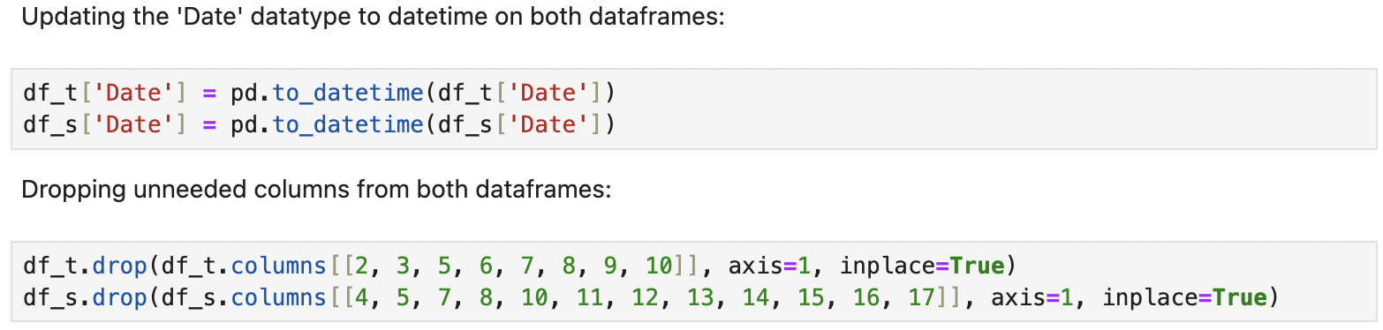

I reviewed the columns and datatypes once more to confirm they were all correct:

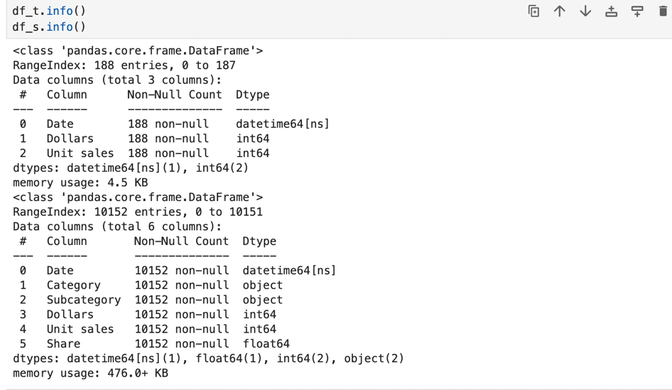

When reviewing the df_s data frame, I noticed that the retail sales were divided up by subcategory for each week but were also included as ‘All foods’: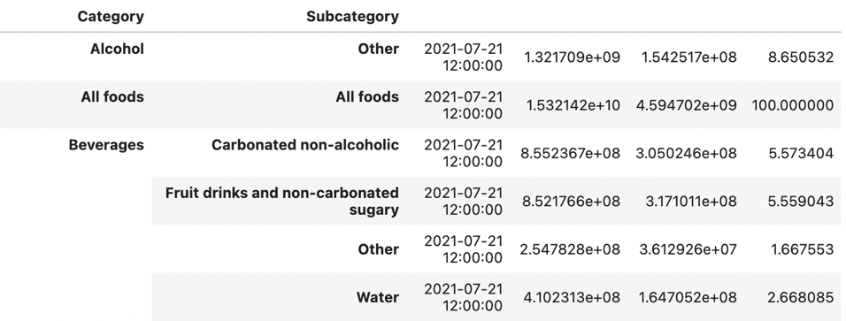

These rows need to be deleted to be able to get an accurate prediction.

The last data preparation step was to add columns to both data frames that calculated the average cost per unit:

Since the number of units also increases, the average dollar amount per unit is needed to make an accurate prediction of future food costs.

# E. Data Analysis Process

## E.1 Data Analysis Methods

I used the Autoregressive integrated moving average (ARIMA) data model to predict future data points using historical data. The ARIMA model is a type of regression model that uses time series data to forecast future data points. ARIMA is a generalization of autoregressive moving average models and is fitted to data to understand or predict future points in a series. This model was the most appropriate analytical method since it can be used with time series data like the weekly retail food cost data we used for this project. This model has been proven effective in forecasting inflation rates in many countries around the world. The data we used was fitted to the ARIMA model which then was able to predict future data points based on the inflation rate of the data we provided.

## E.2 Advantages and Limitations of Tools and Techniques

The project was done using Python in Jupyter notebooks. The Python packages that were used include pandas, numpy, matplotlib, sklearn, DateTime, and pmdarima. The advantage of using Python in Jupyter Notebooks was the various Python packages I was able to use in my analysis as well as Jupyter Notebooks providing an environment to both write and run code as well as create data visualizations. The limitations with Python were working with time series data and the limited options for forecasting the data points needed. The data sets used were from the USDA.gov website and were downloaded in Excel. The advantage of this data was that it was from a trusted source and public data. It was also relatively clean and formatted in an Excel file so it was easy to read and upload. Some formatting had to be done to the Excel spreadsheets before I was able to upload them into Jupyter Notebooks since the datatypes would not have converted correctly in the data frame. The limitations of this data were the limited amount of time the data was for, 2019-2023, so we were not able to provide a historical 5-year inflation rate for comparison. Also, the data was total dollars spent per week and total units sold so we had to add a column to create an average cost per unit. For the forecasting, I used the ARIMA modeling technique. This technique is commonly used for time series forecasting. The advantage of the ARIMA model is that there is an auto ARIMA model in Python that will fit the data automatically, making the process much easier. It is also one of the only accurate models for time series data. The limitation with

ARIMA is the manual ARIMA process of getting the data stationary so the results are accurate.

## E.3 Application of Analytical Methods

## I first plotted the weekly dollars per unit totals to get a visual for the rising costs over the past few years:

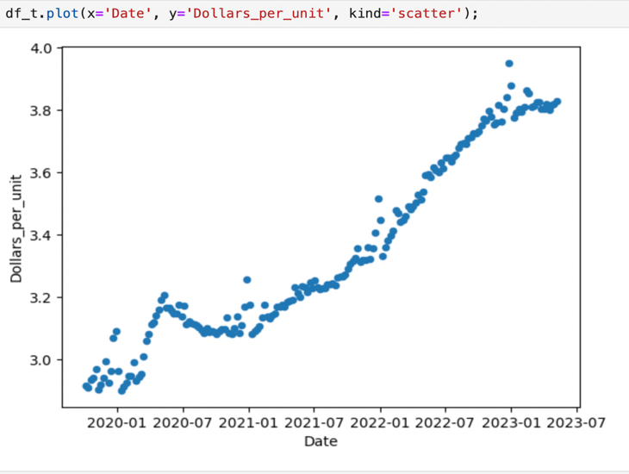

This visual shows a strong positive linear relationship between the cost of food and time.

Starting the ARIMA modeling by creating a data frame with dollars per unit and date as index:

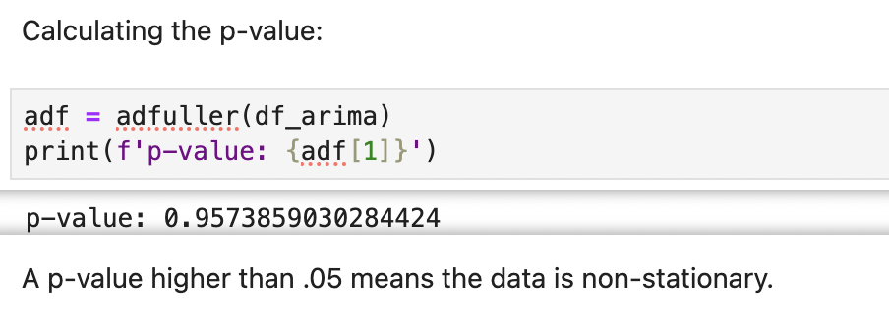

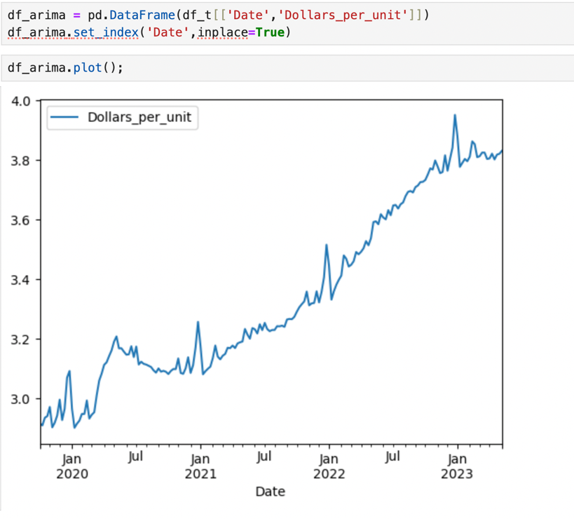

A p-value higher than 0.05 indicates the time series is not stationary. I then used differencing to detrend the data.

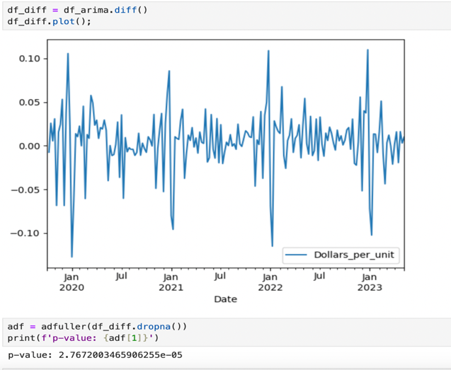

This p-value shows the data is stationary.

I then created a manual ARIMA model:

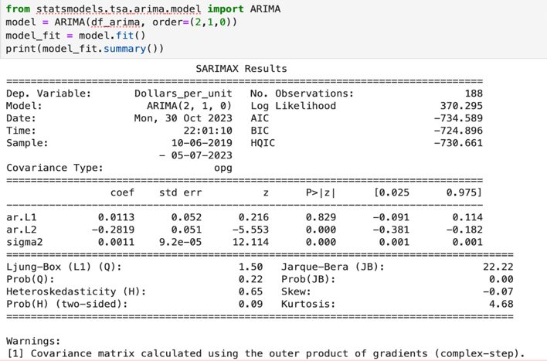

Then an auto ARIMA model:

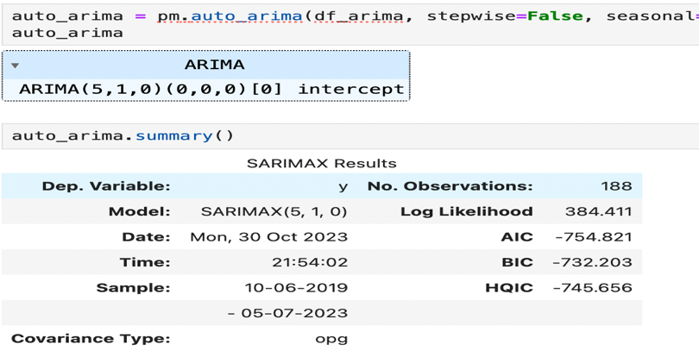

This model was then used to predict future data points:

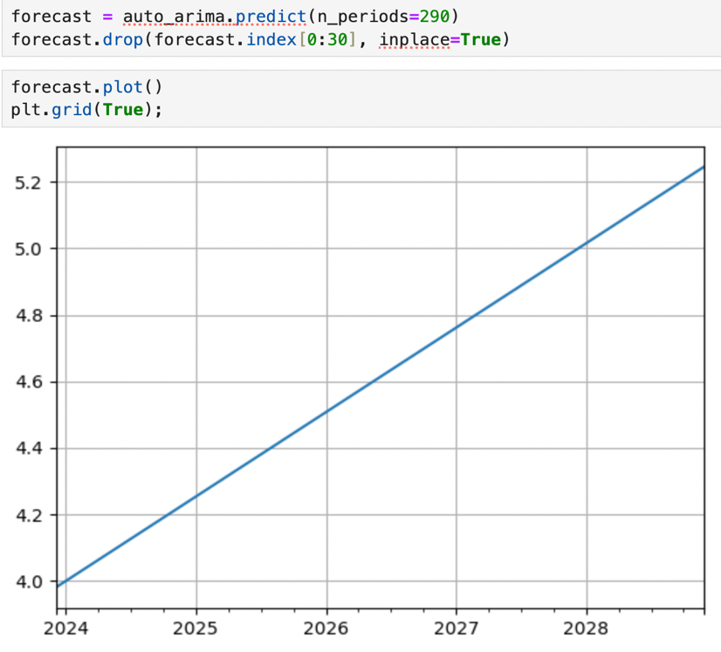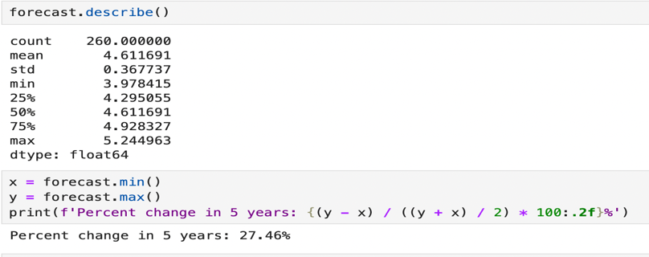

I then created ARIMA models for multiple subcategories of food that showed higher inflation rates and was able to forecast the cost of certain food items in 5 years:

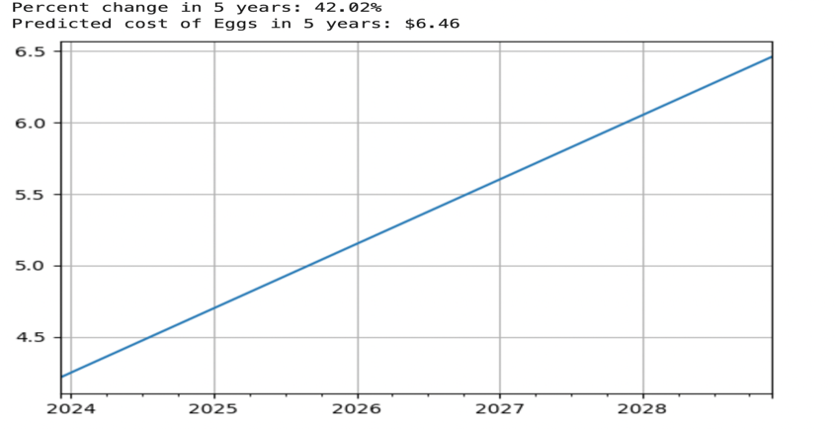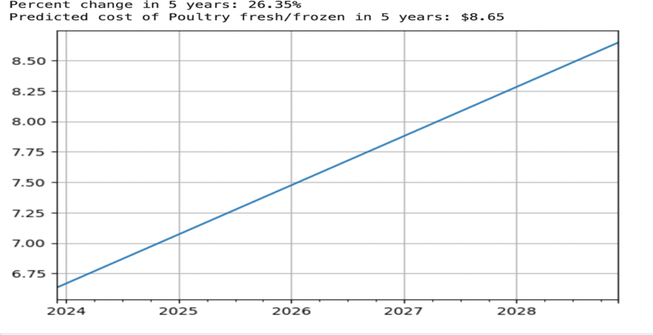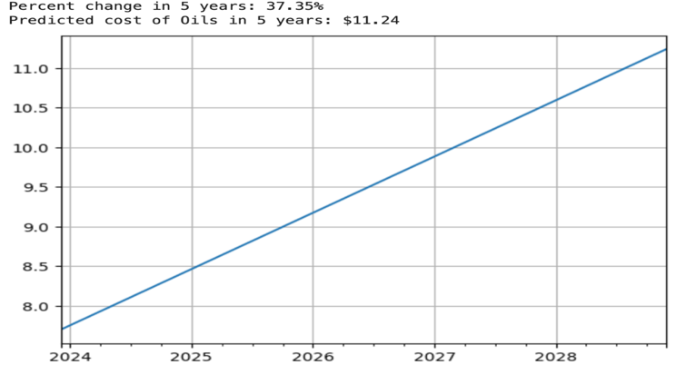

# F Data Analysis Results

## F.1 Statistical Significance

I used the Autoregressive integrated moving average (ARIMA) data model to predict future data points using historical data. The ARIMA model is a type of unsupervised regression model that uses time series data to forecast future data points.

The ARIMA model is represented as ARIMA(p,d,q):

p is the number of autoregressive terms or lags

d is the number of differencing that needs to be done to make the data stationary

q is the number of moving average terms

When manually working with an ARIMA, you ultimately want to figure out the p,d, and q values.

We use the Dickey-Fuller (ADF) test to confirm whether the data is stationary or not. If time series data is stationary, it means that the mean does not vary in time. Most time series data changes through time so it is nonstationary and will need to be transformed using various methods such as differencing to become stationary.

When we used the ADF test, the p-value proved the data was non-stationary. We then used differencing and ADF tests once again to confirm the data was stationary.

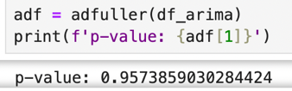

We want to do the least amount of differencing as possible.

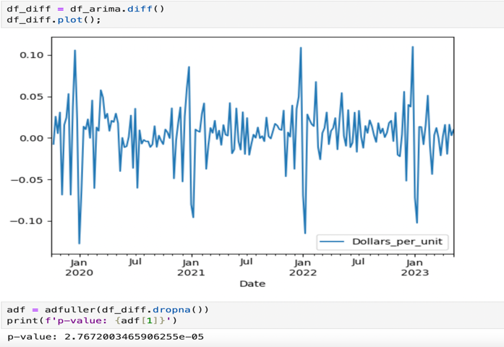

Once we make the data stationary, we can create our ARIMA model and fit it to our data:

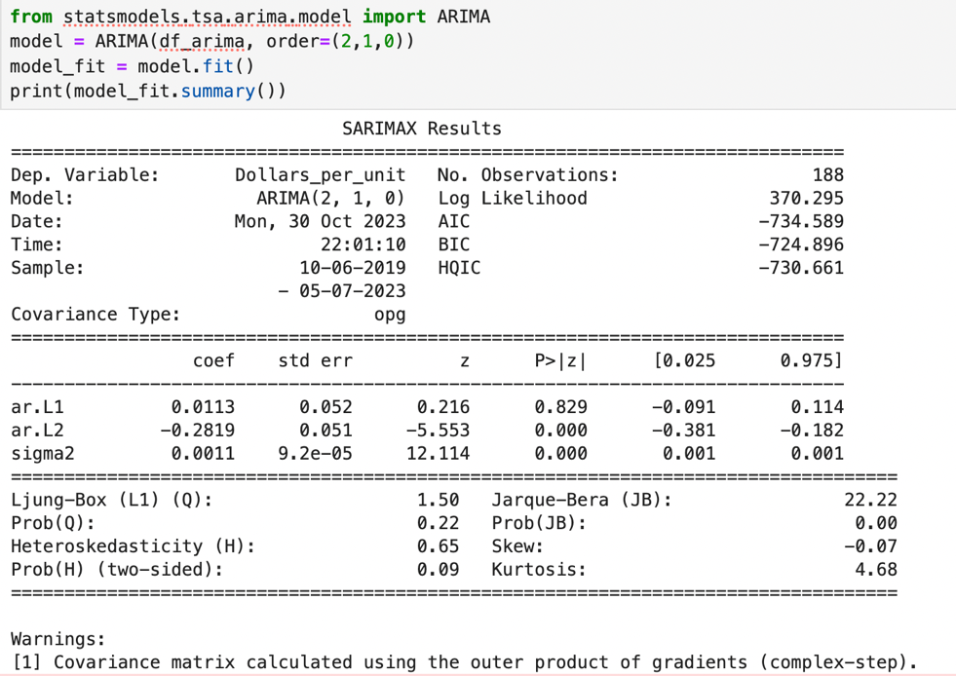

This process, however, can be simplified by using the auto_ARIMA can be used instead. This algorithm automatically finds the optimal parameters for the ARIMA model and we can fit the model without the above steps:

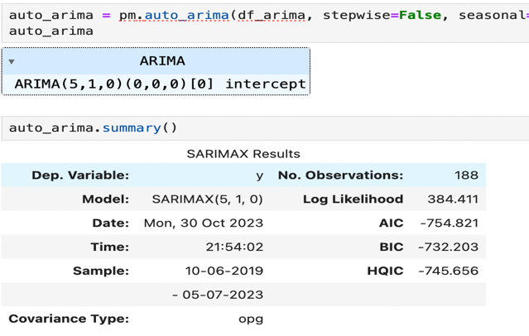

We can then use this model to predict future data points:

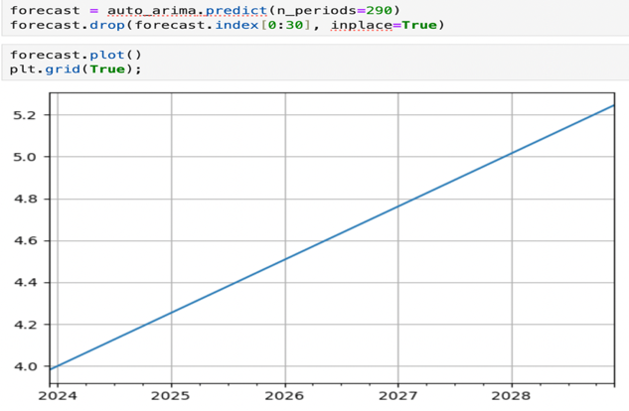

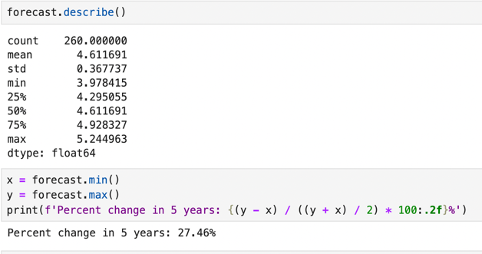

This shows that the forecasted average food cost will rise 27.46% in 5 years.

## F.2 Practical Significance

The practical significance of this project was measured if the ARIMA model predicts a large increase in the cost of food in the 5-year time frame. I large increase would be anything higher than 15% as this is what our current organization could manage with our current infrastructure and funding. If it is higher than 15%, it will be significant for our organization because it will mean we will need to expand to continue to support our community. If food inflation continues to accelerate and rises over the general inflation rate, many families may be faced with food insecurity and need our services.

The practical significance was proven by the extreme rise in food costs forecasted by the ARIMA model. Average food prices will rise 27.46% with certain food subcategory examples like eggs rising by 42.02%, poultry rising by 26.35%, and oils rising by 37.35% in 5 years. This is significant for our organization because it confirms the need to expand to continue to support our community. If food inflation continues to accelerate and rises over the general inflation rate, many families may be faced with food insecurity and need our services.

## F.3 Overall Success

The criteria for success on this project was if we were able to achieve results within 3-5 business days and with one employee working on the project to save on expenses. This was measured by the hours I spent on the project. I was able to forecast the rising food costs in 5 years with minimal resources and on time. I was able to create an ARIMA model to forecast the costs of subcategories of foods as well which were used as examples to give more perspective about the effects of such high increases. We were able to accurately forecast data points using the ARIMA data model and effectively use it to better understand how much food costs will grow in 5 years. This was measured by accurately forecasting the data points needed to find the average percentage change in food costs in 5 years as well as the average unit cost and percentage change for selected food subcategories. This will help confirm the need to expand our nonprofit and request more funding. The analysis found that food costs will rise on average 27.46% in 5 years. Egg costs will rise 42.02% with an average unit cost of $6.46. Poultry will rise 26.35% with an average unit cost of $8.65. Oils will rise 37.35% with an average unit cost of $11.24. This project was a success, we were able to prove the need for our organization to expand as well as gain more funding since we would not be able to provide services with the forecasted costs.

# G. Conclusion

## G.1 Summary of Conclusions

The goal of this project was to forecast the average cost of food in 5 years if inflation continued to accelerate at the rate it currently is. Our nonprofit organization trying to determine if we need to expand our services and obtain more funding due to the accelerated rise in food costs in the last few years. To be able to maintain our current level of services, food costs will need to stay under a 15% rise in 5 years. We want to forecast the cost of food and see if expansion and more funding are needed immediately to ensure we can continue helping the community. The data we are using if from the USDA.gov website and includes the weekly retail food sales for the nation from 2019-2023. This will be used to forecast future food costs. Since we were working with time series data, we built an ARIMA model to accurately forecast the future data points. The findings forecast that food prices will rise an average of 27.46% in 5 years. I was able to create a function that would forecast the costs of foods by subcategory. The examples created we eggs at $6.46 per unit which is a 42.02% raise, poultry at $8.65 per unit which is a 26.35% raise, and oils at $11.24 per unit which is a 37.35% raise.

## G.2 Effective Storytelling

The tools and graphical representations used for this project have been successfully used for inflation forecasting many times in the past. Graphical representations are an important piece of the ARIMA modeling process. Many visualizations were used that display the forecasted data points as well as the different subcategories of food.

This first scatterplot shows the weekly average food cost per unit from 2019-2023. The second scatterplot shows the weekly average food cost per unit from 2019-2023 by food subcategory.

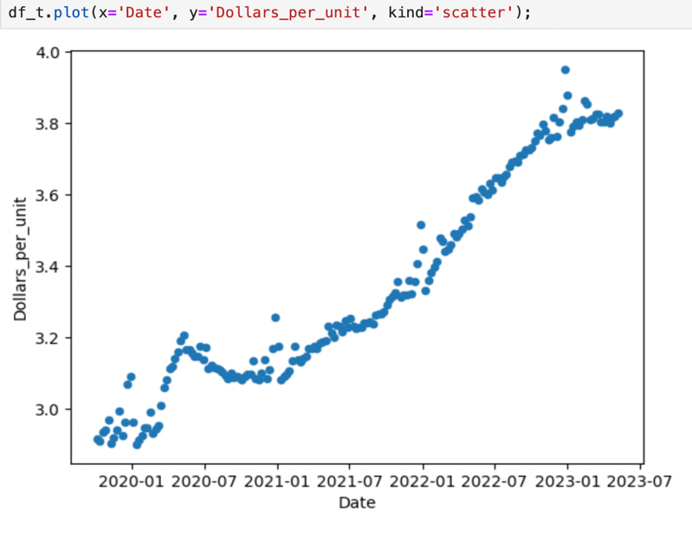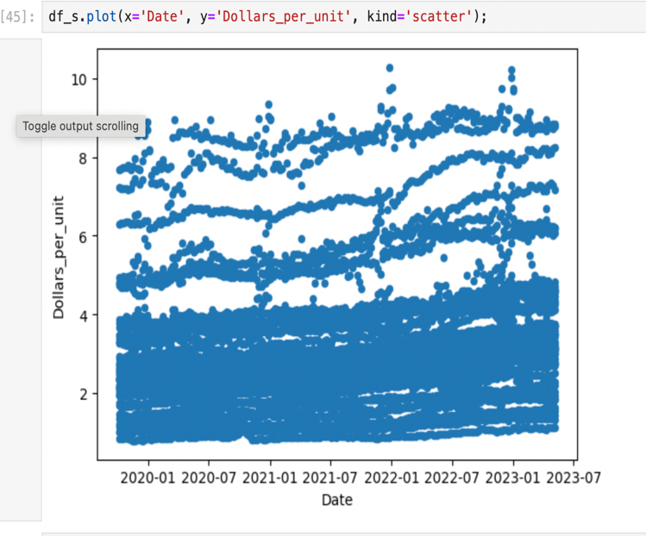

To better visualize the weekly average food cost per unit from 2019-2023 by food subcategory, I have created the below plot that effectively shows the change in cost over time for each food subcategory. The colors represent each week in the dataset, we can see certain foods have a much larger cost increase over the timeframe than others. I choose eggs, poultry and oils as my food cost examples since they had much larger cost increases than most of the other subcategories.

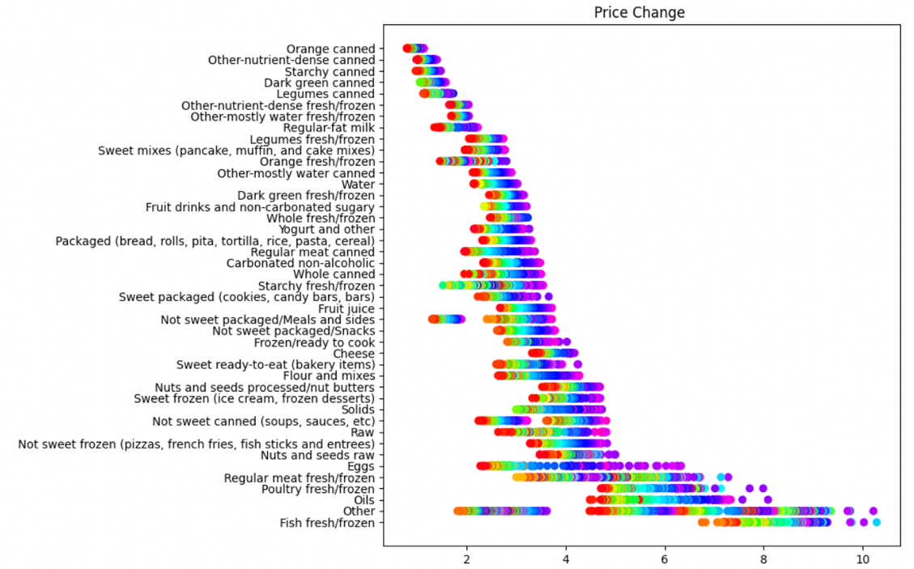

This visualization shows the weekly average food cost per unit in a plot:



This visualization shows the differencing process used when creating a manual ARIMA model:

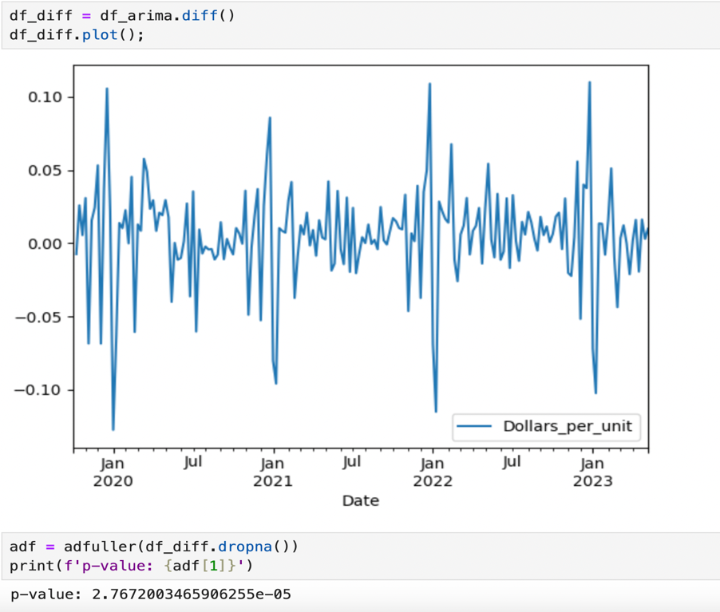

Once the auto ARIMA model was created and fitted to our data, this is the plot showing the forecasted food costs in 5 years:

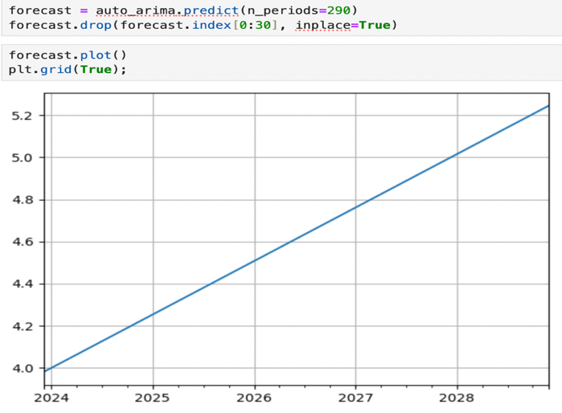

The last three visualizations show the average cost per unit rise in percentage and in dollars for our examples: eggs, poultry, and oils.

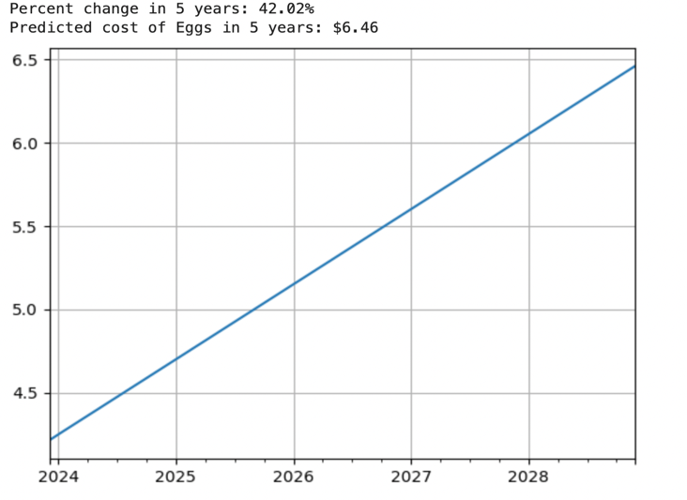

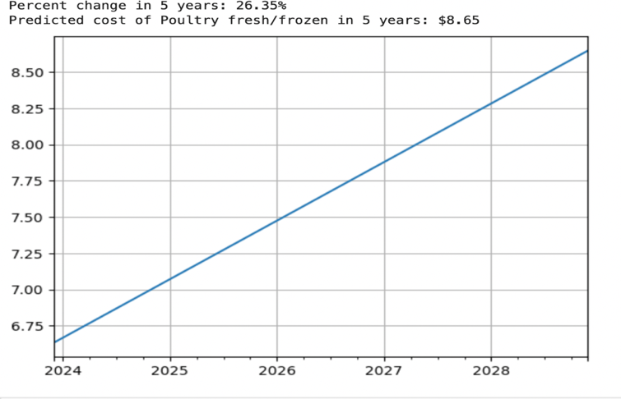

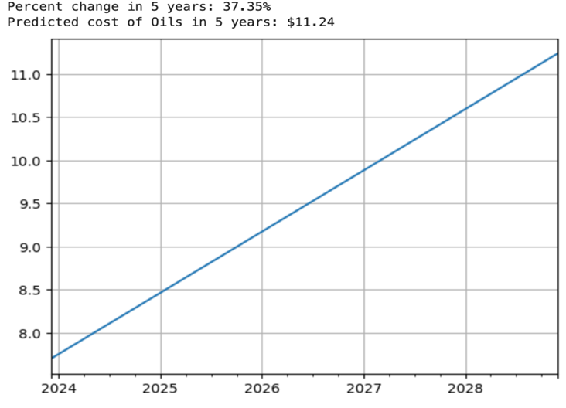

## G.3 Recommended Courses of Action

* Based on the data, I would suggest immediate planning for the expansion of Feeding Families Organization. With food costs projected to rise by an average of 27.46%, we will need a larger facility and possibly open a new location.
* I would also suggest using this data to create a presentation to show potential donors to raise more funding. With the cost rising and plans to expand the organization, Feeding Families will need a lot more funding moving forward.

# H Panopto Presentation

**https://wgu.hosted.panopto.com/Panopto/Pages/Viewer.aspx?id=9f6eabda-4d27-478d-b546-b0b0004f4d9e**  
 

# References

Kontopoulou, V. I., Panagopoulos, A. D., Kakkos, I., & Matsopoulos, G. K. (2023). A Review of ARIMA vs. Machine Learning Approaches for Time Series Forecasting in Data-Driven Networks. *Future Internet*, *15*(8), 255. MDPI AG. Retrieved from http://dx.doi.org/10.3390/fi15080255

Patton, M. (2023, September 3). *Food prices outpace general inflation: Here’s what you need to know*. Forbes. https://www.forbes.com/sites/mikepatton/2023/08/30/food-prices-outpace-general-inflation-heres-what-you-need-to-know/?sh=4d05d3096fbd *United States Food InflationSeptember 2023 data - 1914-2022 historical*. United States Food Inflation - September 2023 Data - 1914-2022 Historical. (n.d.). https://tradingeconomics.com/united-states/food-inflation Hannon, P. (2023, August 4). *Inflation is cooling. food inflation could get worse.* The Wall Street Journal. https://www.wsj.com/articles/inflation-is-cooling-food-inflation-could-get-worse-bb373e06 urdue University. (n.d.). Retrieved from APA Formatting and Style Guide (7th Edition) - Purdue OWL: https://owl.purdue.edu/owl/research_and_citation/apa_style/apa_formatting_and_style_guide/index.html

Scribbr. (2022, December 21). *Free Citation Generator*. Retrieved from Scribbr: https://www.scribbr.com/citation/generator/

Smith, J. (2023). A Generic Journal Article Example. *Generic Journal*, 50-62.

Okafor, C., & Shaibu, I. (n.d.). Application of Arima models to Nigerian inflation dynamics - core. https://core.ac.uk/download/pdf/234629451.pdf

Wikipedia contributors. (2023, October 9). Autoregressive integrated moving average. In Wikipedia, The Free Encyclopedia. Retrieved 14:30, October 29, 2023, from <https://en.wikipedia.org/w/index.php?title=Autoregressive_integrated_moving_average&oldid=1179339959>

Adjemian, M. K., Arita, S., Meyer, S., & Salin, D. Factors affecting recent food price inflation in the United States. *Applied Economic Perspectives and Policy*. <https://doi.org/10.1002/aepp.13378>